CS 340 README

About the Project/Project Title
This project is a Python module that provides CRUD (Create, Read, Update, Delete) functionality for the Austin Animal Center (AAC) outcomes dataset stored in MongoDB. For this milestone, the focus is on the Create and Read operations. The module is designed to be reusable, so other Python scripts or applications (such as dashboards) can import it and interact with the AAC database.

Motivation
The motivation behind this project is to bridge the gap between a MongoDB database and a Python based application layer. It brings database operations into a clean, object-oriented module so developers can build user interfaces or analytics tools without rewriting database logic. This approach also enforces best practices in authentication, error handling, and modular design. Python was optimal to enhance the MongoDB table with sorting, filtering, and pagination, add a pie chart showing breed distribution, and to add a geolocation map showing the selected animal’s location.

Getting Started
First step is to import the AAC outcomes dataset into MongoDB.
This is the command prompt:
mongoimport --type=csv --headerline --db aac --collection animals --drop ./datasets/aac_shelter_outcomes.csv
Next, create a user through the admin database in MongoDB with read/write access.

Installation
Prerequisite tools:
- MongoDB:
  - Stores semi-structured AAC outcomes data in flexible JSON-like documents.
  - Integrates seamlessly with Python via PyMongo.
  - Supports complex queries (e.g., $in operators for breed filtering).
- Dash (Plotly):
  - Provides the view (widgets, charts, tables) and controller (callbacks).
  - Enables rapid development of interactive dashboards in pure Python.
- Dash Leaflet:
  - Used for geolocation mapping with markers, tooltips, and popups.
- Pandas:
  - Handles data manipulation and conversion between MongoDB query results and dashboard components.
- Plotly Express:
  - Simplifies chart creation (pie charts, bar charts, etc.) with concise syntax.
- Base64 Encoding:
  - Embeds the Grazioso Salvare logo directly into the dashboard.
- An .env file that looks like:
AAC_USER=aacuser
AAC_PASS=yourpassword

Prerequisite dependency:
pip install pymongo

Usage

Code Example

The Create User Process:
use aac
db.createUser({
user: "aacuser",
pwd: "ChooseAPassword",
roles: [
{ role: "readWrite", db: "aac" }
]
})

from CRUD_Python_Module import AnimalShelter
load_dotenv()
# Instantiate with credentials
username = os.getenv("AAC_USER")
password = os.getenv("AAC_PASS")
shelter = AnimalShelter(username, password)
# ----------------------
# CREATE example
# ----------------------
doc = {
"animal_id": "A000000",
"name": "Floof", # fixed quotes
"breed": "Beagle",
"outcome_type": "Adoption"
}
print("Insert successful:", shelter.create(doc))

# ----------------------
# READ example
# ----------------------
results = shelter.read({"breed": "Beagle"})
print("Number of results:", len(results))
for r in results[:2]:
print(r)

# ----------------------
# UPDATE example
# ----------------------
# Let's change Floof's outcome_type from Adoption to Transfer
update_count = shelter.update(
{"animal_id": "A000000"}, # query
{"outcome_type": "Transfer"} # new values
)
print("Number of documents updated:", update_count)

# Verify update
updated = shelter.read({"animal_id": "A000000"})
print("Updated record:", updated)

# ----------------------
# DELETE example
# ----------------------
delete_count = shelter.delete({"animal_id": "A000000"})
print("Number of documents deleted:", delete_count)

# Verify delete
after_delete = shelter.read({"animal_id": "A000000"})
print("Record after delete:", after_delete)

Tests
Testing was performed in the provided ModuleFourTestScript.ipynb Jupyter Notebook,
ProjectOneTestScript.ipynb Jupyter Notebook, and the ProjectTwoTestScript.ipynb.
Create Test: Inserted a new document and confirmed True was returned.
Read Test: Queried by breed and confirmed results were returned as a list.
Update Test: Queried for a specific record (e.g., by animal_id or name) and updated one of its fields (such as changing the outcome_type from "Adoption" to "Transfer"). Confirmed that the method returned a count of 1 and that a subsequent read() query showed the updated value in the database.
Delete Test: Queried for the same record and deleted it. Confirmed that the method returned a count of 1 and that a subsequent read() query returned an empty list, verifying that the record was successfully removed.

Challenges and Solutions

- Empty Query Handling:
  - Issue: read({}) initially returned no results because {} evaluated as False.
  - Solution: Modified read() to accept empty dicts as valid queries.
- ObjectID Column:
  - Issue: MongoDB returned _id fields of type ObjectID, which caused the DataTable to crash.
  - Solution: Dropped the _id column from the DataFrame before rendering.
- Geolocation Columns:
  - Issue: Dataset column indices for latitude/longitude varied.
  - Solution: Added defensive checks for column names (location_lat, location_long) and fallback coordinates.

Screenshots
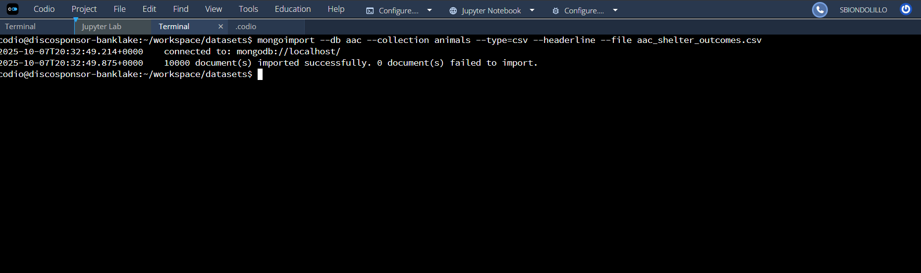
The screenshot shows the terminal in Codio where the mongoimport command was executed to load the Austin Animal Center Outcomes dataset into MongoDB. The command specifies the target database (aac), the collection (animals), and the CSV file (aac_shelter_outcomes.csv).
In the output, MongoDB confirms a successful connection to localhost and reports that 10000 documents were imported into the aac.animals collection. This verifies that the dataset is now available in MongoDB for use by the CRUD Python module and the client-facing dashboard.

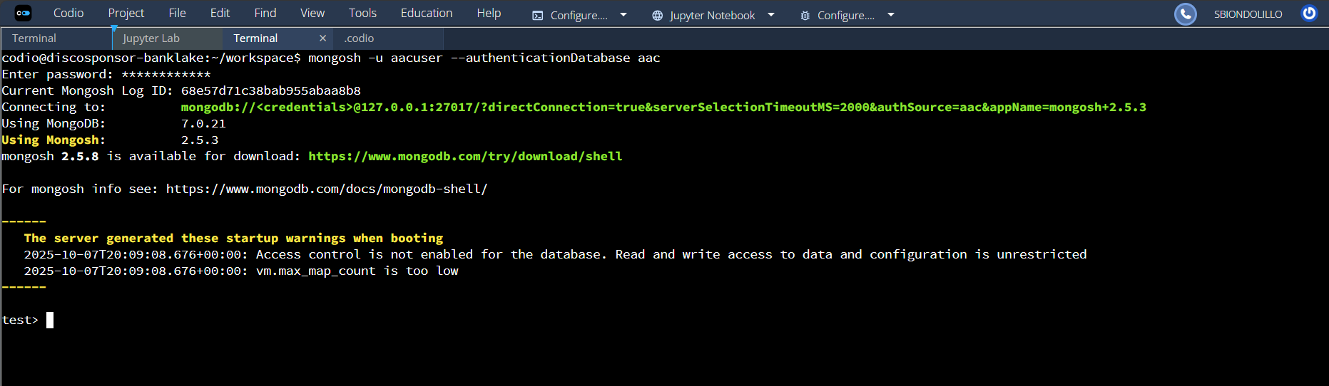
This shows an example of a successful connection to the database with read access under the new user created.

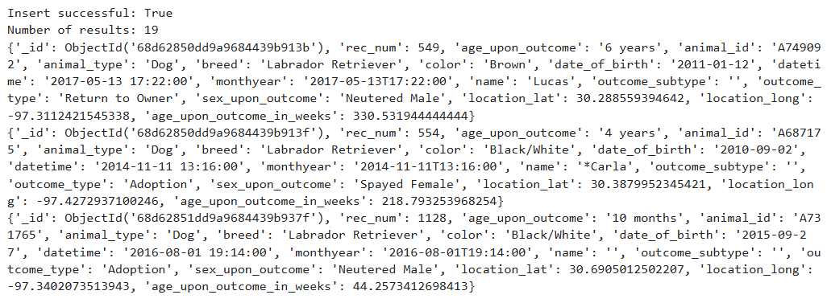
This screenshot demonstrates that the Read functionality of the CRUD Python module is working correctly, retrieving multiple documents from the database and returning them in a structured format suitable for further analysis or display in the dashboard.

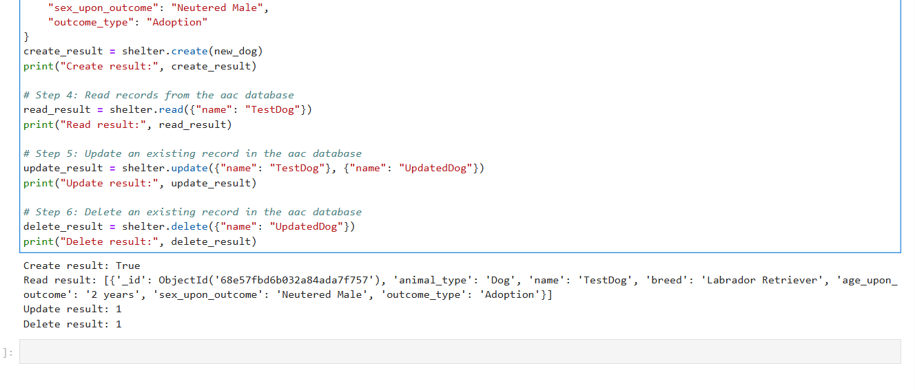
This screenshot captures the execution of the full CRUD workflow using the AnimalShelter Python class. The test script demonstrates each core operation:
- Create: A new dog record is inserted into the aac.animals collection, confirming that the database accepts new entries.
- Read: The inserted record is retrieved using a query, verifying that the data is accessible and correctly stored.
- Update: The dog’s name is modified from "TestDog" to "UpdatedDog", showing that existing records can be altered.
- Delete: The updated record is removed from the collection, confirming that the system can cleanly delete entries.
Each operation returns a clear result. It’s either a success flag, a list of matching documents, or a count of modified/deleted records. This confirms that the CRUD module is functioning as intended and can be reliably used by client-side applications to manage animal data.

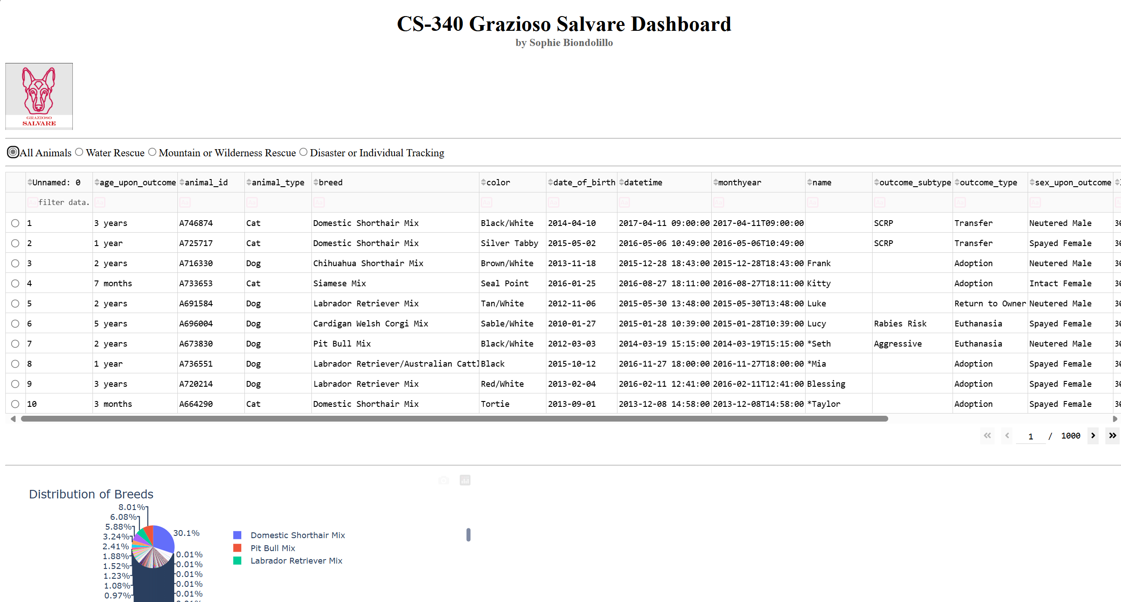
This screenshot shows the main page for the dashboard. Here you can sort the data by many factors, scroll through all types of breeds shown by the pie chart, or choose another view than “All Animals.”
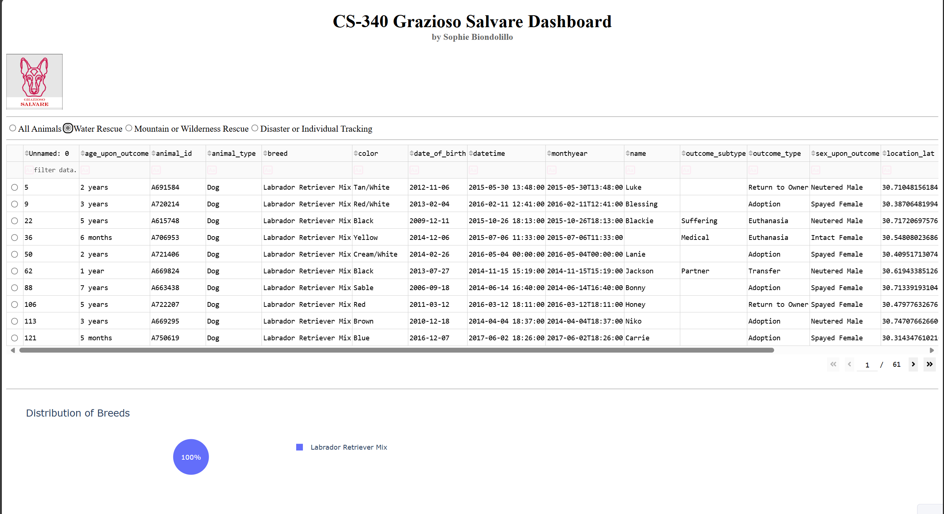
This is the “Water Rescue” view. You can see that the pie chart shows only one breed of dog for this type of Search and Rescue operation.
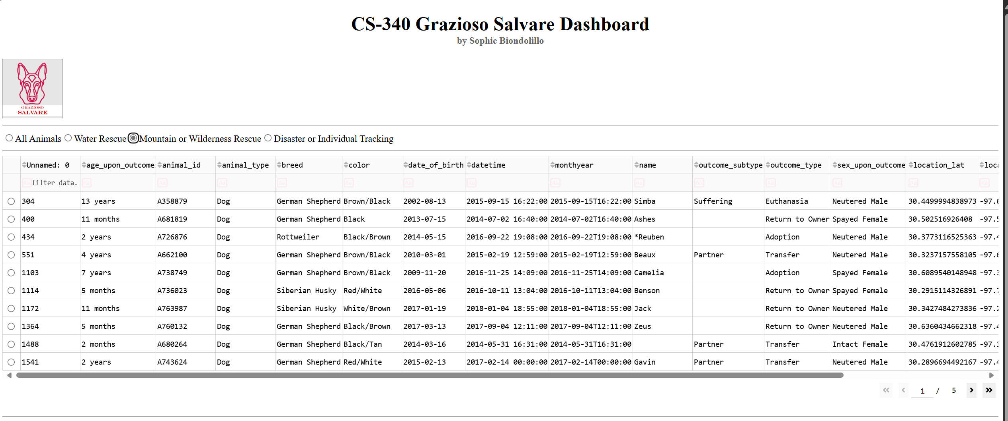
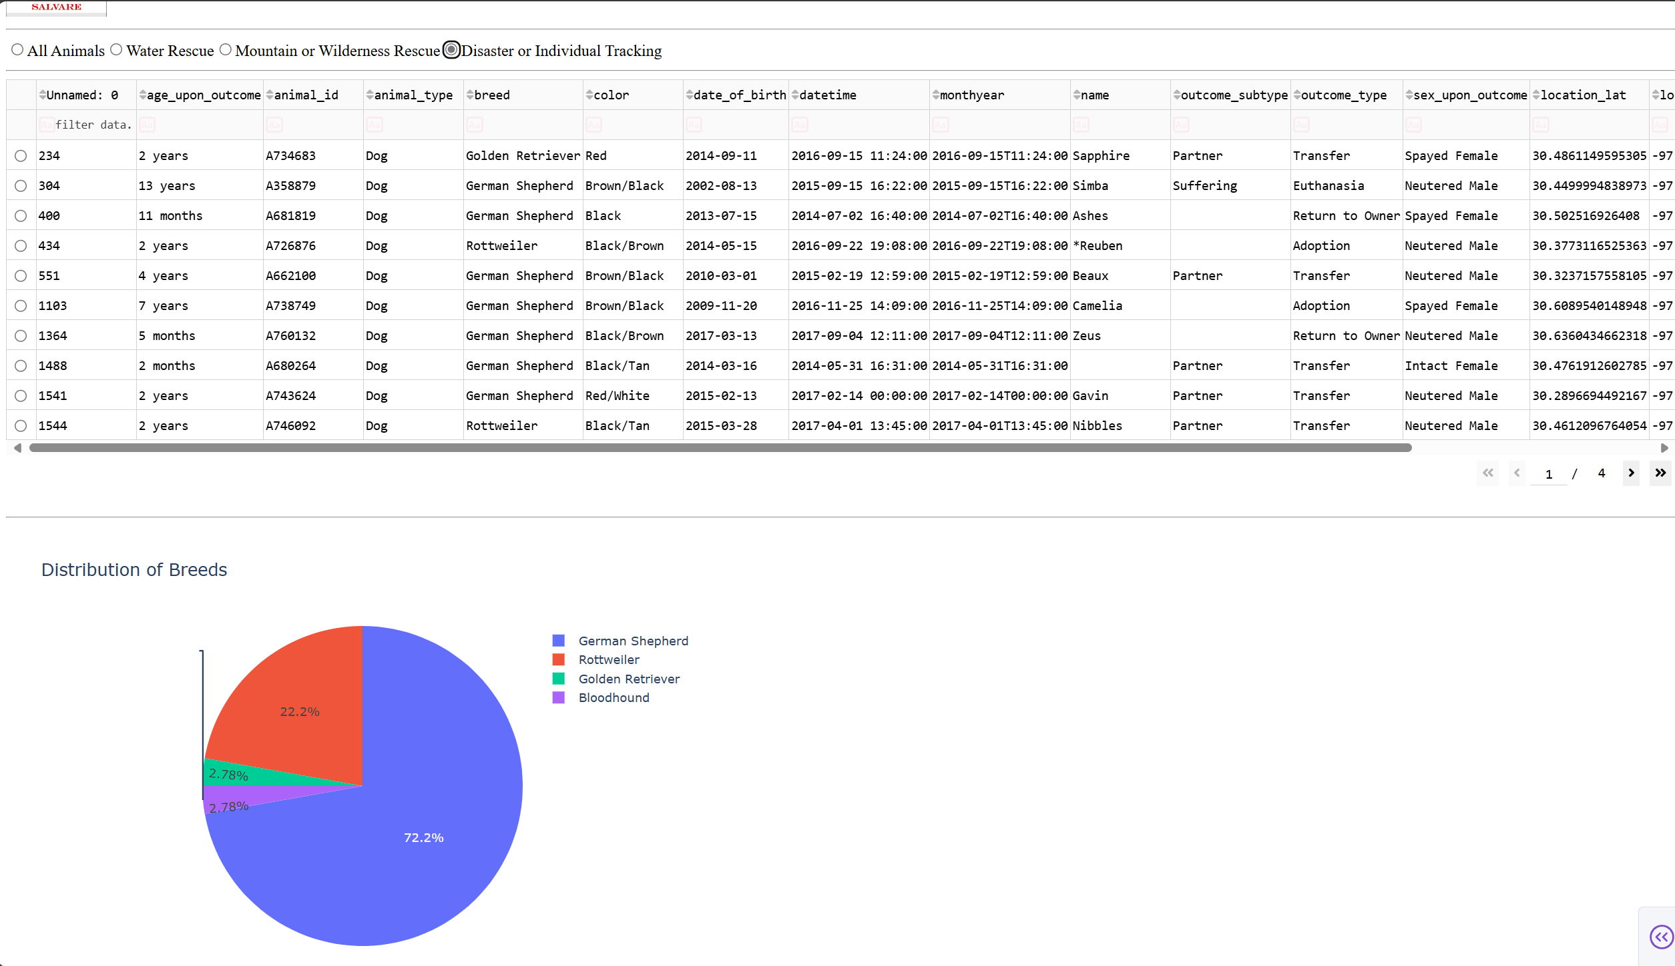
Staff can quickly filter animals by rescue type (Water, Mountain/Wilderness, Disaster/Tracking) to see which dogs are currently available for specialized missions. The interactive table makes it easy to sort by breed, age, or outcome type, helping coordinators assign the right animal to the right task.

Roadmap/Features (Optional)
Future implementations:
Expand error handling and logging.

Contact
Sophie Biondolillo

